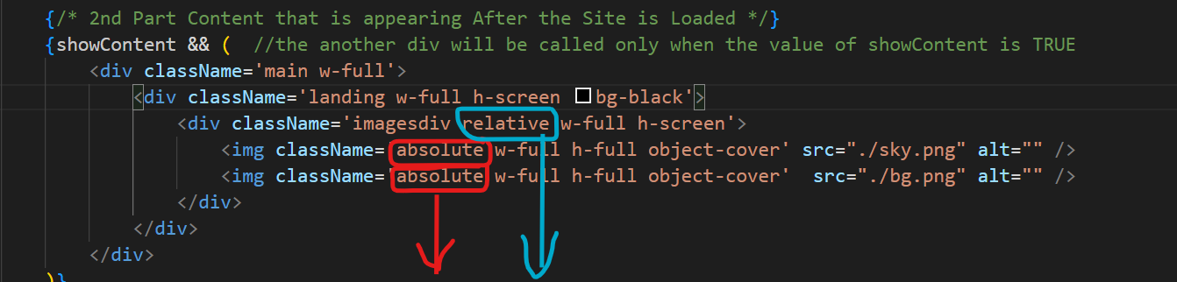**GSAP----->**GSAP (GreenSock Animation Platform) is a JavaScript animation library used for creating smooth and high-performance animations on the web

Now without **ABSOLUTE** the Images appear ***one after the other*** but we want the images to be on ***EACHOTHER*** therefore we make use of **ABSOLUTE**

And after that we make the **DIVISION TAG** i.e. the resp. **Section** of the page **REALTIVE** so that it remains in the same ***SECTION/DIVISION*** of the page





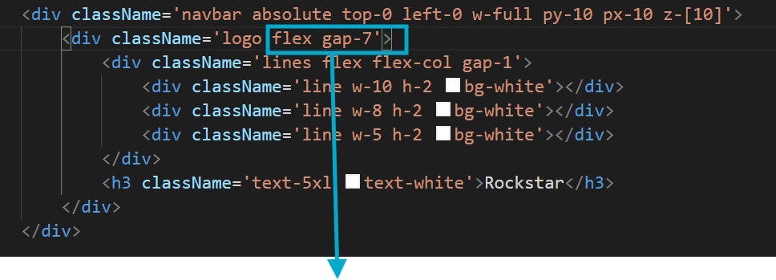means that the image will not go down the respective section



**FLEX: -** So that the ***TEXT*** and the ***IMAGE*** are Next to each other and there is a ***GAP*** between them.